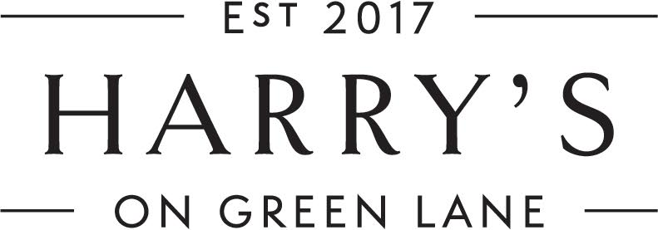

Welcome to Harry’s on Green Lane.

Our wine bar and bistro is called Harry’s after the renowned English nurseryman and horticulturist, Sir Harry Veitch who dispatched daring plant hunters to foreign lands to find exotic treasures for his wealthy London clientele.

Harry Veitch was also the founder of the Chelsea Flower Show, a great entrepreneur and the owner of the largest nursery in London. Through his “plant hunting” he is recognised for finding most plants in modern gardens today.

Dinner

Entrees

Pacific Oysters (A)
Natural - mignonette sauce
½ doz. 30 1doz 58
Rockefeller - baked with cheese and spinach
½ doz. 33 1doz 60

Tuna Tataki (I)
Pea puree, pickled daikon, ponzu sauce with sesame oil
24

Burrata
Roasted pumpkin, hummus, heirloom radish, herb panko crumbs, balsamico
22

Beef Carpaccio
Thinly sliced tenderloin, fried capers, saffron & anchovy aioli,
pecorino cheese, basil & chive oil
25

Chicken Ballotine
Apricot, pistachio and currant stuffing, romesco sauce, herb oil, micro herbs
23

Prawn & Avocado Tian (vegan optional) (I)
Pickled cucumber, tomato salsa, chilli herb dressing, lavoche
(Vegan option – replace prawns with charred brussel spouts)
23

Main Course

Crab Linguine (I)
Blue swimmer crab, garlic, tomato, chilli,
white wine, lemon, herbs
40

Lamb Ragu
Slow braised lamb, pappardelle, pecorino, basil oil
44

Linguine with Pesto Pasta (vegan)
Basil pesto, tomato, chilli flakes
35

Market Fish of the Day (M)
Roast potatoes, heirloom dutch carrots, roasted corn and fennel puree,
caper berries, baby tomatoes, naval orange, herb cream
44

Duck Confit
Parish mash, brussel sprouts with sundried tomatoes, orange sauce
45

Beef Rib
Braised beef rib (off the bone), green beans, dutch carrots,
honey roasted sweet potato puree,
chimichurri,red wine jus
46

Steak Frites
Wagyu rump mb+4, shoestring fries, bearnaise sauce
48

Pork Cutlet
Seared pork cutlet, pickled cabbage, caramelized apple,
dutch carrots, jus
43

Sides

Harry’s Garden Salad
Mixed lettuce,naval orange, cherry tomatoes,
Parmesan cheese, lemon dressing
14

Oven Roast Potatoes
Pecorino, lemon oil
13

Dutch Carrots
Roasted with vincotto & pecorino
14

Brussel Sprouts
Pine nuts, pecorino, lemon dressing
14

Truffle Fries
Parmesan, parsley
15

All side dishes are vegan optional

See over - Desserts

Dessert

Harry’s Bread & Butter Pudding
Crème Anglaise, orange, rose petals
17

Poached Pear(vegan optional)
Cranberry sauce, mascarpone,
roasted almond crumbs
17
Crème Brulee
With vanilla beans from Madagascar, topped with crystallized toffee.
Break it and be overwhelmed.
17

Affogato
Ice cream, espresso, frangelico
21

Cheese
Barber’s Cheddar,
Berrys Creek Mossvale Blue,
muscatels, truffle honey, crackers
24

(A)Australian (M) Mixed (I) Imported

15% surcharge applies on public holidays

