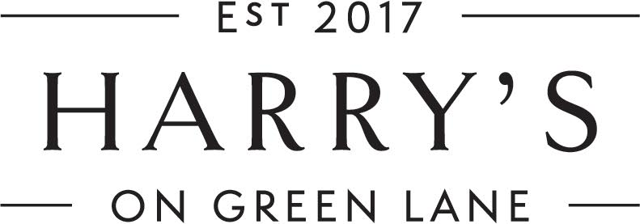

Welcome to Harry’s on Green Lane.

Our wine bar and bistro is called Harry’s after the renowned English nurseryman and horticulturist, Sir Harry Veitch who dispatched daring plant hunters to foreign lands to find exotic treasures for his wealthy London clientele.

Harry Veitch was also the founder of the Chelsea Flower Show, a great entrepreneur and the owner of the largest nursery in London. Through his “plant hunting” he is recognised for finding most plants in modern gardens today.

Lunch

Entrees

Bread
Fresh Sourdough 4.95

Today’s Soup
Delicious, ‘house made’ fresh sourdough
Entrée 24 Main Course 30

Duck Terrine 24
Mixed lettuce, fig jam, sourdough

Pacific Oysters (A)
Natural - mignonette sauce
½ doz. 30 1doz 58
Rockefeller - baked with cheese, spinach, panko crumbs
½ doz. 32 1doz 60

Battered Scallops (I) 23
Mango & coriander chutney, wasabi aioli

Smoked Salmon (I) 24
Charred guindilla peppers, radish, baby capers, labneh

Burrata (vegetarian) 20
Roasted pumpkin, hummus, radish, panko crumbs, balsalmic

Arancini (vegetarian) 20
Mixed lettuce, chipotle mayo, parmesan

Main Course

Crab Linguine (I) 39
Blue swimmer crab, garlic, tomato, chilli,
white wine, lemon, herbs

Winter Risotto (vegan optional) 37
Sundried tomatoes, roast brussel sprouts, rocket, pinenuts, pecorino

Chicken Fricassee 39
Mashed potato, green beans, baby carrots,
Tuscan mushroom cream sauce

Braised Lamb Shoulder 40
Mashed potato, Dutch carrots, green beans, mint jus, tzatziki

Beef Rib 40
Braised beef rib (off the bone), green beans, Dutch carrots
honey roasted sweet potato puree,chimichurri, red wine jus

Today’s Market Fish (M) 39
Roast potatoes, heirloom carrots, roast corn & fennel puree,
baby tomatoes, naval orange, caperberries, herb cream

Prawn Saganaki (I) 38
Artichoke, kalamata olives, oregano, chilli flakes, tomato sugo,
crumbled fetta, grilled sourdough

Sides

Harry’s Garden Salad 14
Mixed lettuces, naval orange, cherry tomatoes,
Parmesan cheese, lemon dressing

Roast Chat Potatoes 13
Pecorino, lemon oil

Dutch Carrots 14
Roasted with vincotto & pecorino

Shoestring Fries 12
Sumac salt, paprika aioli

Truffle Fries 15
Parmesan, parsley

Dessert

Harry’s Bread & Butter Pudding 16
Crème Anglaise, orange, rose petals

Poached Pear (vegan optional) 16
Cranberry sauce, mascarpone, roasted almond crumbs

Crème Brulee 16
With vanilla beans,
topped with crystallised toffee

Cheese 24
Barber’s Cheddar,
Berry’s Creek Mossvale Blue,
muscatels, truffle honey, crackers

- Australian. (I) Imported (M). Mixed

15% surcharge applies on public holidays

